
-

I(indekiIer

monoblock directional control valve
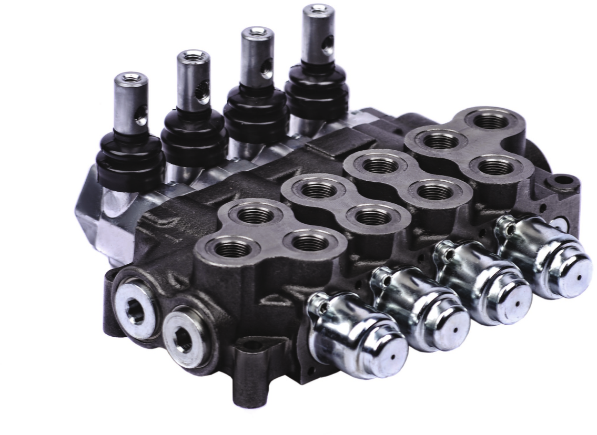
monoblok hidrolik yân kontrol valfi

Product Features  Urun 0zeIIikIeri | i‹
General Specifications  Genel 0zeIIikIer | i‹
Order Coding  Sipari§ Kodlama | I5
Dimensional Data   | i6
Performance Data  Perlormans Egrileri | 17
Hydraulic Specification  Hidrolik Devre | i8
Inlet Options  Basing (P) Hatti Opsiyonlari | 19
Spool Positioners  S”urgu Kontrolleri | 2s
Spool Options  S’urg'u Tipleri | 27
Lever Types
Sap tip/eri
Outlet Options
Tank (T) Hatti Opsiyonlari

General Specifications
Senel Ozefiikler

Product Features
AMV50 is an ideal control valve for nominal flow rate 50 Ipm and operating pressures up to 350 bar. With its unique design AMV50 a wide application range.
Accessories
Valve is equipped with an adjustable main relief valve Avaliable in parallel (in standard) and series circuit Load Hold Check valve
Wide range of spool options Interchangable 016 mm Spools Carry-over and closed center option Controls
Manual, Pneumatic, Electro- Pneumatic, Hydraulic, Electro-
Hydraulic, Solenoid, Inlet Proportional, Mechanical Joystick and Remote Cable Control
Ozellikler
AMV50 serisi 50 ltfdk ve 350bar’a kadar maksimum performansi g‘osteren, geli§mi# ozellikleriyle birqok mobil uygulama izin ideal kontrol kumandasidir.
Aksesuarlar
Ayarlanabilir Ana Emniyet Valfi Paralel Devre ve Seri Devre i kani Yuk Tutma Valfi
}e§itIi Surgu Tipleri Degi§tirilebilir BI6 mm Surguler
6arry-over ve Kapali Merkez Imkani
I 0fitr0/
Manuel, Pnomatik, Elei‹tro-Pnomatik, Hidrolik,
Elei‹tro-HidroIik, Direk Elektrik, Giri§ Oransal, Mekanik
Joystik, Halat Control

Standard Material Specifications Standard Malzeme Ozellikleri

High Resistence Cast Iron Body Dokum Oovde
Hard Chromium Plated Interchangable SpoolS Sertle§tirilmi§ Krom Kaplama Surg’uler
Steel spring caps §eIik Yay Kapaklari Aluminium Lever Caps Aluminium Sap Kapaklari NBR Seals IEBR Sizdirmazlik Elemanlari

Recommended 0iI Viscosity Range Onerilen Yag Vizkozite Araligi 10 cst IO 75 cst
Recommended Fluid Temperature Range Onerilen §ali§ma Sicakligi (°0) -20 to +80

Environmental Temperature Range Onerilen Ortam S/cay//y/ (°C)
-40 to +60

Maximum Contamintation Level Maksimum Kirlilik Seviyesi Class JO (NAS J638) J9/J6 (ISO 4406)

Nominal FIoW Debi
Number of SpoOIS Dilim Sayisi 1 - 7

Maximum Working Pressure Maksimum §aIi§ma Basinci
Maximum Back Pressure Maksimum Tank Haiti Basinci 30 bar

Internal Leakage i Kayak Oegeri
50 lpm

350 bar
250 bar in Series Circuit

4 cc - 9 cc
(100 Bar: 32 cst. 40°C)
13 US gpm

5000 psi
3600 psi in Series Circuit

0,24-054in3/m
(1450 psi: 32 cst. 104°F)

Order Coding 
Siirgri Kontrolleri
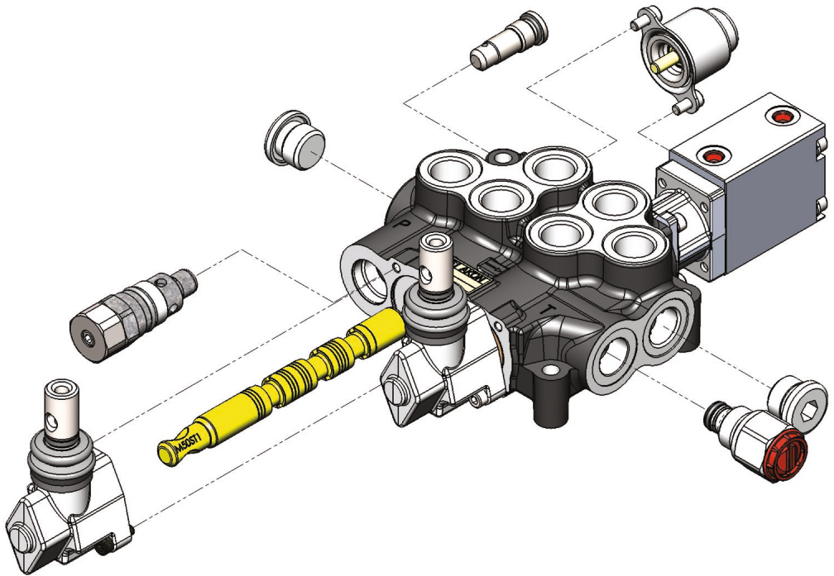S+“R^+i) Eodlama
ST
Surgu Tipleri
Basin§ (P) Hatti Opsiyonlari
Tank (T) Hatti Opsiyonlari
Sap Tipleri

AMV502A - R(180) - SC1 ST11 KI / SC15 STI KI / H
1 2 3 4

Valve Type v«ir ripi
AMV50 Valve Series vslf Serisi
2 Number of Spools SifirgiJ Sayisi
A Port Thread Port âI§ifileri

Working Section Dims

SC1 Spool Positioners S’urgu Kontrolleri
ST11 Spool Options Surgu Tipleri
KI Lever Types Sap Tipleri

Inlet Options Pompa (P) Hatti Opsiyonlari

R Main Relief Valve Ana Emniyet Valfi
180 Pressure Setting Basing Degeri


Outlet Options Tank (T) Halts Ops/yon/an

H Outlet Options Task Haiti Opsiyonlari

Y

This part must be coded seperately for each working section. If adjacent sections are identical then code the first section and put number of identical sections with a cross. Example for 3 identical sections; AMV504A-R(180)/SC1ST1/3XSC4ST1
Bu bolumdeki kodlama her dilim izin ayri ayn yapilmalidir. Eger birbirini takip eden ve ayni konfigiirasyona sahip dilim isreniyorsa, agm di/im/er, dilim say/s/ ba#a getirilip yanina parpi Jronaca£ §eyi/de
kodlanabilir. Ornek Kodlama; AMV504A-R(l80)fS8lSTli3XS84STl

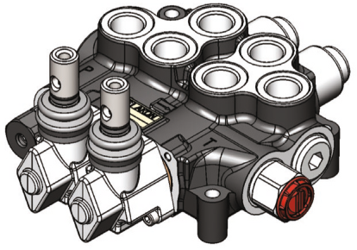 B Pan Tarafi
Pam a Hatti - P Yan
ompaHan-rilu I
Dimensional Data
0/yi?se/ Bilgi
Tank Hatti - T1 (Ust)

Standard & Optional Threads Standard ve Ops/yone/ 0lq5ler
Tank Hatti - T(C0)

BSP(Standard)
A | G3/8” | G3/8” | G1/2" | G1/2"
B | GI/2” | GI/2” | G1/2” | G1/2”

UN-UNF | L | 3/4-16(SAE8) | 3/4-16(SAE8) | 7/8—14(SAE 10) | G 1/2”
UN-UNF | M | 7/8—14(SAE 10) | 7/8—14(SAE 10) | 7/8—14(SAE 10) | G 1/2“

METRIC | U | M18x1,5 | M18x1,5 | M22x1,5 | G 1/2"
 | Z | M22x1,5 | M22x1,5 | M22x1,5 | G 1/2”

BSP threads are standard threads. Its necessary to code the port thread after valve series during ordering in monoblock valves. Example coding; AMV502B-R(1601/SC1ST1
Valllerimiz standart olarak BSP Did dreti/me/‹tedir. Talep ed//en port olyâleri monoblok va/f/erde valf tipi kodlamasindan /iemen sonra kodlanir. Ornek God/anna; AMV502B-R(I60)fS8lSTI
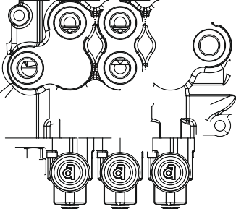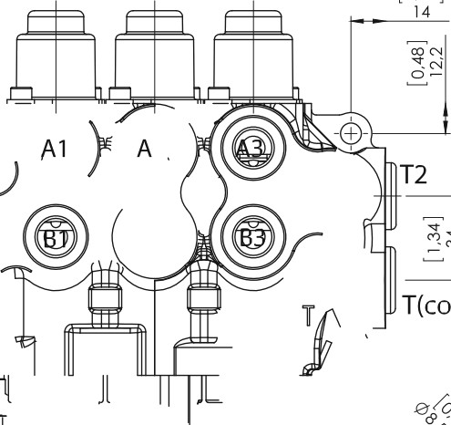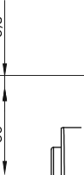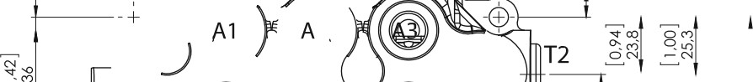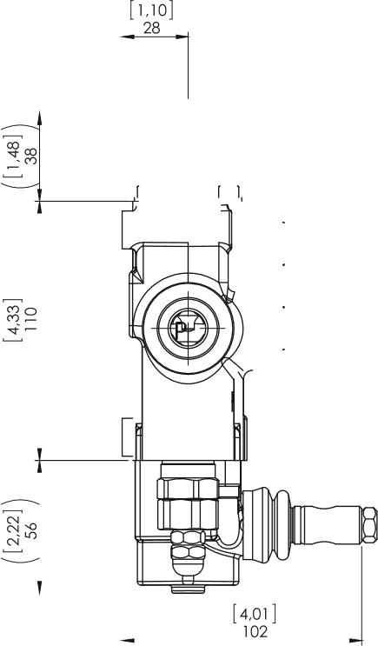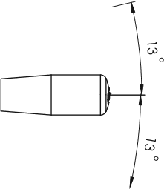
}
T(co)
!’27"
‹u
Dimensions 6 Weight Old’dler ve Agirlik

mm | inc | mm | inc | kg | lb

AMV501 | 80 | 3.15 | 121 | 4.76 | 3.50 | 7.70
AMV502 | 120 | 4.72 | 161 | 6.34 | 5.90 | 13.00
AMV503 | 160 | 6.3 | 201 | 7.91 | 7.15 | 15.75
AMV504 | 200 | 7.87 | 241 | 9.49 | 8.60 | 18.95
AMV505 | 240 | 9.45 | 281 | 11.06 | 10.65 | 23.50
AMV506 | 280 | 11.02 | 321 | 12.64 | 12.30 | 27.10
AMV507 | 320 | 12.6 | 361 | 14.21 | 13.50 | 29.75
Given weights are for standard configurations.
Agirliklar standan korfigurasyon izin veriImi#tir.

Performance Data
Pe/ormans E§rileri

Pressure Drop Curves Bas/ny Kayip Egrileri

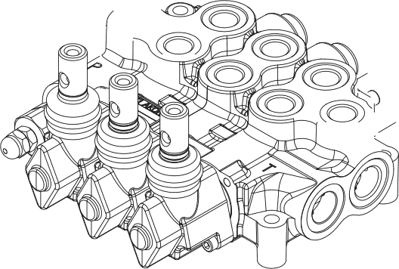P - T

.\p
PSI Ba r
290 20
250
200 15
150 10

100
5
50
0 0
0 20
0 5.2

40

10.5

AMV506

AMV504 AMV502

60 %*
15.8 US—GPM

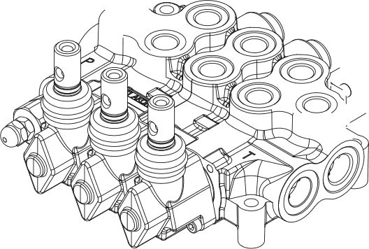P - @B
PSI Bar
290 20

20 15

150 10
100
5
50
0 0
0 20

0 5.2

40

10.5

P - As(B6)
P — A4(B4)
P - Az(B2)

60 !e

15.8 US GPM

@B - T
PSI Ba r
290 20
250
IS
200

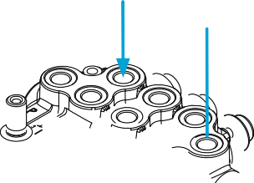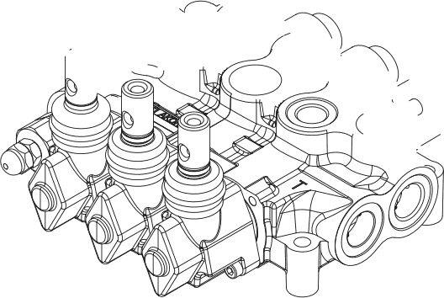150 10

100
5
50
0 0
0

0

20

5.2

40

10.5

Az(Bz) - T

A6(B6) - T

60 *e+
15.8 US—GPM

Measured with spool type ST1 and 32 cst hydraulic oil @ 40°C.
STI surgu ve 32 est hidrolik yag ile 40”C’de ol§uImtI§tur.


Hydraulic Specifications
Hidrolik Devre

Parallel Circuit Para/e//?ev're
NO
CODE

Standard configuration; Parallel circuit with upper inlet and outlet.
Standard konfig”urasyon; Parallel devre, PI ve if a§ik, P, T2 ve T(C0) kor §ekIindedir.

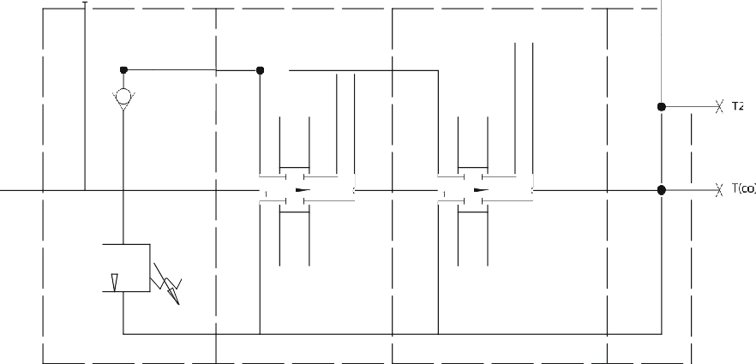
P1

Series Circuit Seri fievre
P1
A1 BI

A1 B1
A2 B2 TI
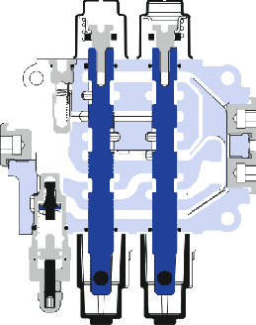

A2 B2 T1 

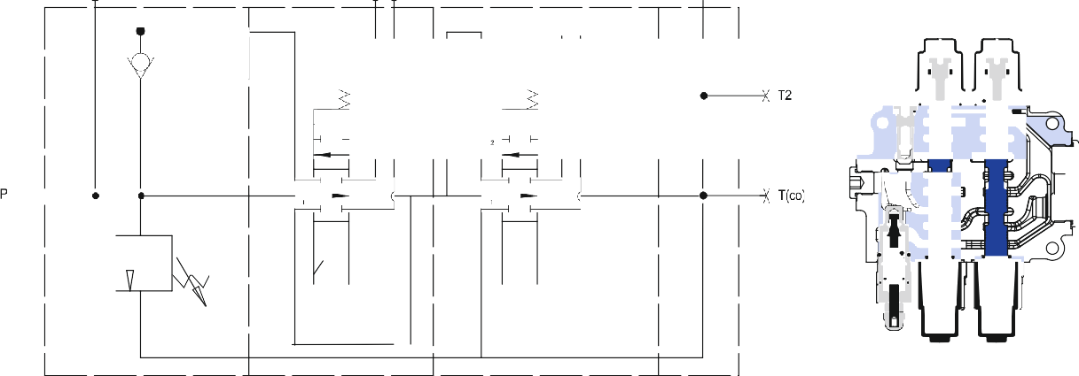

Maximum working pressure is 250 bar.
Maksimum §ali§ma basinci 250 bar.

Series Circuit is coded with «S» before each series working section demanded. Example Coding; AMV502A-R(200)/SSC1ST1/SSC1ST1
Seri devre her ser/ dilimin ânâne «S» gelecek §ekiIde kodla» r. a nek Kodlama; AMV502A-R(200JlSS0lSTIfSS0lSTI

Inlet Option
8asfny (P) Ha<+ +RsiyonIari

AMV501A - R(180) / SC4 ST11 K3 / H

Pressure setting value(please indicate the necessary pressure in bar)
Basing Ayar Degeri

^ Relief Valve Options
Ana Emniyet Vaifi Opsiyonlari
R

Adjustable Direct Acting Main Relief Valve Ayarlanabilir Ana Emniyet Vaffi /d7rek Etkili)
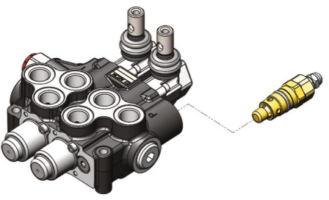
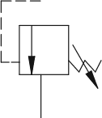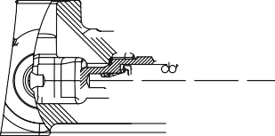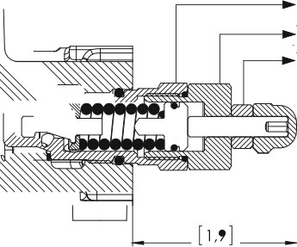

Please indicate the necessary pressure setting value. MRV is preset to 180 Bar at 15 Ipm unless otherwise speficied.
Lñtfen ayerlenmesini istediginiz besinp degerini bildiriniz. Ur5nler stendart olerek IS ItIdk’da 180 Bara ayarlanir.

Main Relief Valve Blanking Plug £mn/yet ¥’affs/z
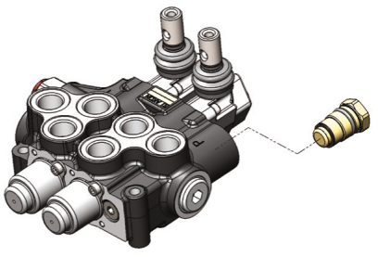
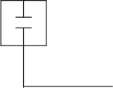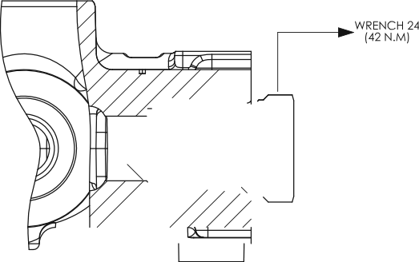
Main Relief Valve Performance Data Ana Emniyet Vaffi Performans Egrisi

PSI BAR
4350 300

3600

2900

2175

1450

725

0

250

200

150

100

50

0

140 BAR / 2000 PSI

— 250 BAR / 3600 PSI

Measured with 32 est hydraulic oil @ 40°C and neglected tank line pressure.
32 est hidrolik yag ile 40°0’de, tank hatti basinci ihmal edilerek âIg5Im“ufiâr.

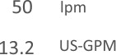
0
10

0 2.6
20
S.2
30 40
7.9 10.6

Spool Positioners
Sârgâ fontrofiezi

AMV501A - R(180) / SC4 ST11 K3 / H

Spool Positioners
Surge Kontrolleri
Spool Positioners with Spring Return Yay D nfi§lifi S’flrg5 'ontroffer

S C 1 S C 5
3 Pozisyon Yayli
2 Pozisyon Yayli

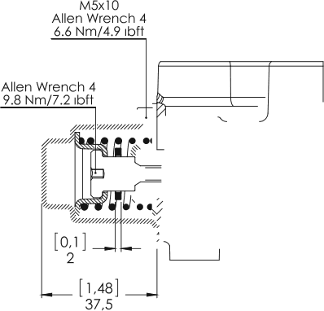2 1 3
2 1 3

Stroke : +5.5 mm
2 2 1

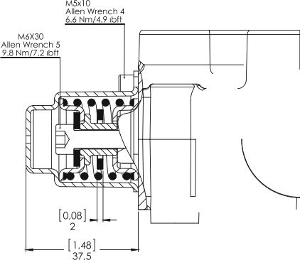Stroke : -5.5 mm

C 1 1
2 Pozisyon Yayli
2 Pozisyon, 3. Pozisyona Yayli

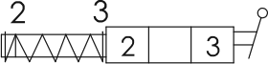
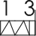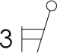

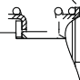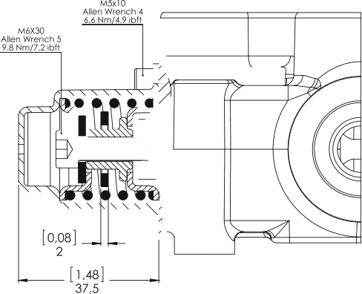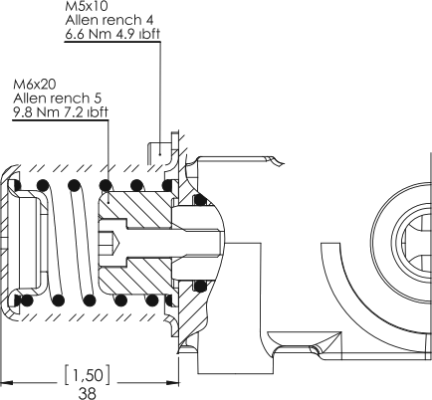Stroke : +5.5 mm Stroke : +11 mm

C 1 2
2 Pozisyon, 2. Pozisyona Yayli
3 Pozisyon Yayli, M8 Erkek Uzatmali

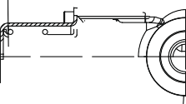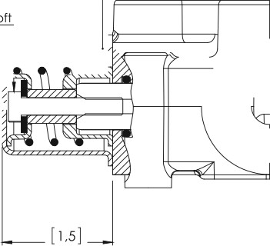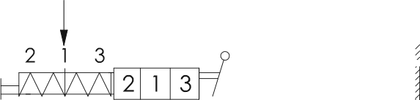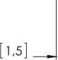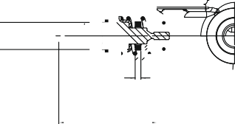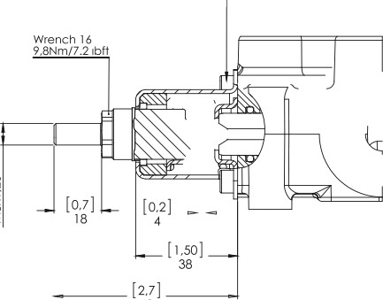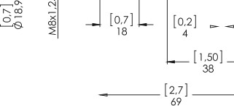Allen Wrench 4
Stroke : +5.5 mm

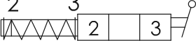
2 3
Stroke : -11 mm

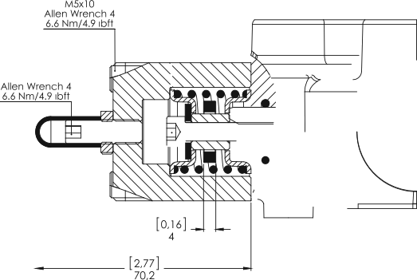S C 3 3
3 Pozisyon Yayli, Strok Limitleyici

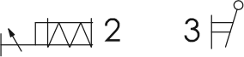
Stroke : +5.5 mm (Max.)/ -5.5 mm

Spool Positioners with Detent Detantli S5rgfi/fontro//er/

S C 2
3 Pozisyon Yayli, 3.Pozisyon Detantli

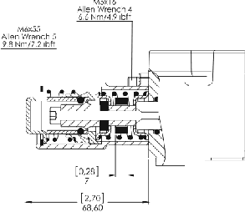

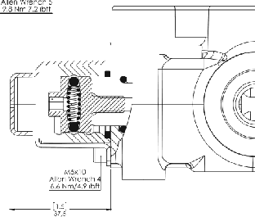
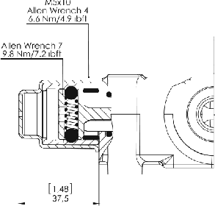

2 Pozisyon Detantli

2 1 3

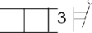Stroke : *5.5 mm
3 Pozisyon Detantli
2

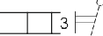2 1 3
2

Stroke : *5.5 mm

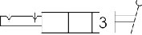
l 3
Stroke : -I-5.5 mm
S C 3
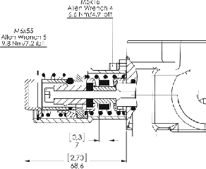

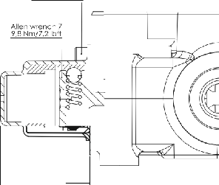
[*”’ ”

 2 PozisyonDetantli
3 Pozisyon Yayli, 2.Pozisyon Detantli
2 Pozisyon Detantli
S C 1 3

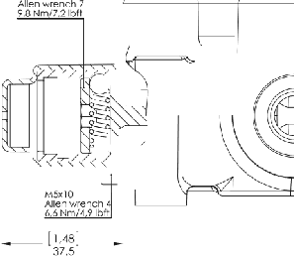

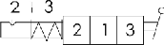
Stroke : + 5.5 mm

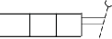2 1
’

Stroke : -5.5 mm

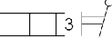2 3
2

Stroke : -I-11 mm

S C 28
3 Pozisyon Yaylive Detantli

Allen wrench #

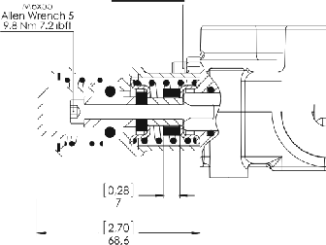2 1 3
Allen Wrench S

2 1 3

Stroke : *5.5 mm

4 Position a Side Spool Positioners 4 Pozisyon d Tarafi S5rg5/fontro/ier/

S C 2 3
4 Pozisyon Yayli, 4.Pozisyon Detantli
4 Pozisyon Yayli, 4.Pozisyon Detantli

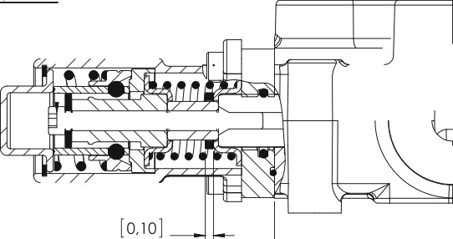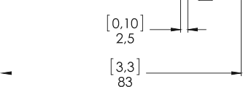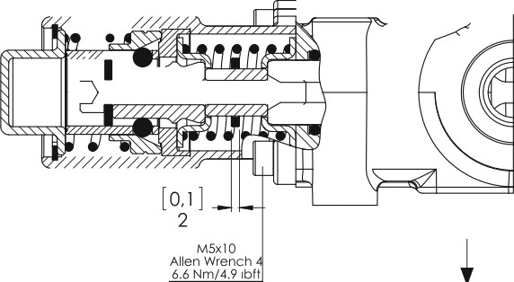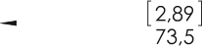Alien Wrench 4
Allen Wrench 5
4
2

2 |  | 3 | 4

2 |  | 3

Used with Spool ST9B Stroke : +5.5 mm / +5 mm
ST9B Surg“u ile kullanilir
Used with Spool ST9A
ST9A S“urg‹l ile kullanilir
Stroke : +5.5 mm / -4.5 mm

C 1 0

S C 2
4 Pozisyon Turn Pozisyonlar Detantli
4 Pozisyon Turn Pozisyonlar Detantli
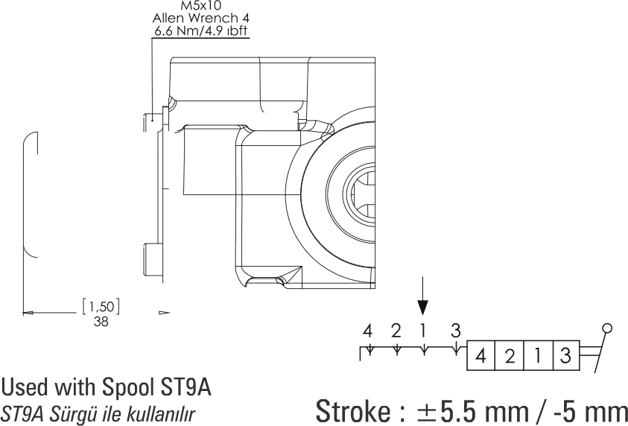Allen wrench 4

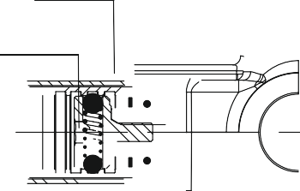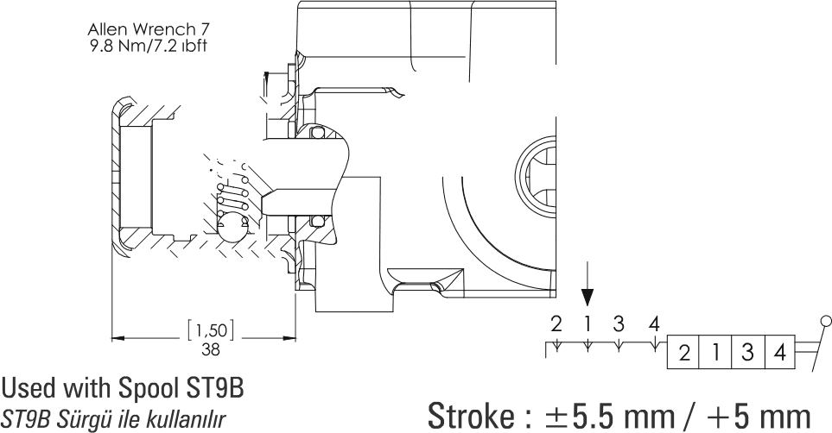

S C 2 1 S C 2 2
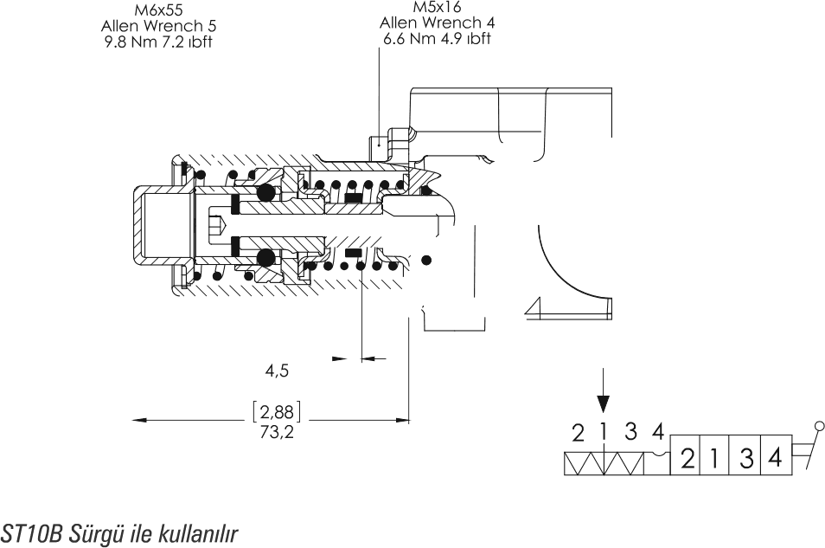 4 Pozisyon Yayli, 4.Pozisyon Hissetmeli Detantli 4 Pozisyon Yayli, 4.Pozisyon Hissetmeli Detantli
[0,2]
Used with Spool ST10B
Stroke : *5.5 mm / +3.5 mm
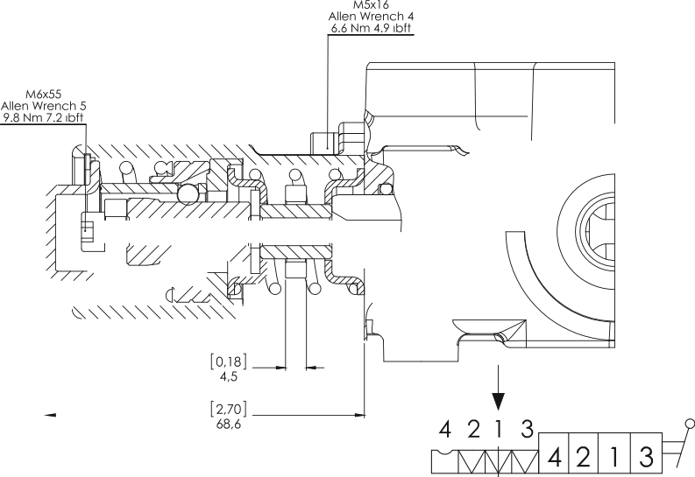
Used with Spool STI 0A
STIOA Surg5 ile kullanil Stroke : *5.5 mm / -3.5 mm

22 Monoblock Directional Control Valves | Monoblok Hidrolik Yân Control Valfleri

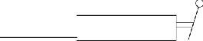S C 1
On-08 Pnomatik Kontrol
2 1 3
2
3
l
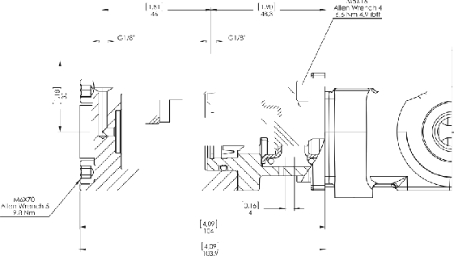

Min. 6 Bar i 85 PSI
Max. 12 Bar 1 170 PSI

+5,5 mm

S C 3 0
0n-0ñ Elektro-Pndmatik Kontrol

Min. 6 Bar 185 PSI
Coil Connection Type
Bobin Baglanti Tipi
Suppy Voltage
to/faj
Protection Type
Koruma
Nominal Voltage Tolerance
/Vomina/ Voltaj Toleransi
Duty cycle
6orev §evrimi
Absorbed Power
6’up

Coil Insulation Class
Yalitirn Sinrfi

Maximum Temperatures
Maksimum §aIi§ma Sicakllgi
Pilot Pressure
Pilot Basinci
Max. 12 Bar i 170 PSI

DIN 43650
Voltage

2VDC
3 2
3 4
24VDC

I2VDC, 24V06
IP65
+ 10%
§ |  | 2 | 1 | 3

S C 1
100%

D6 8W
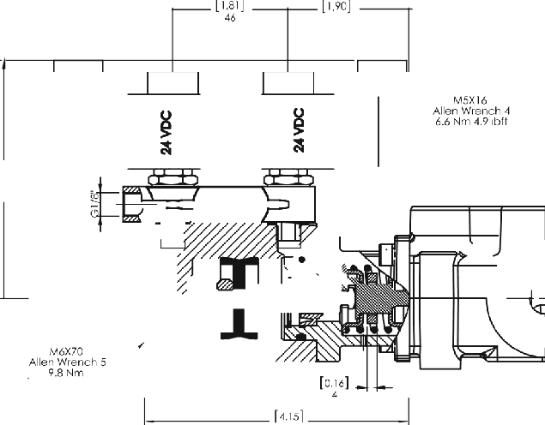
OIass ”H”coi/ as from the IEC 85 standard. Olass ”H”wire (200° C).
Stroke (mm)
Sfrol fmm/
Kit Order Code
Kit Sipari§ Kodu
+5,5 mm
12VDC - 2005712000
24VDC - 2005448000

DI6SS “F” l55°6
Olass “H” I80°C

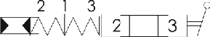

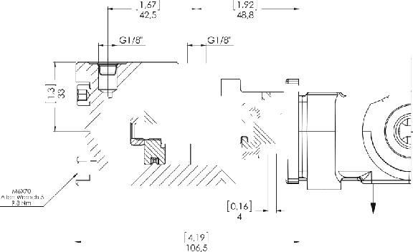
*5,5 mm
On-0ff Hidrolik Kontrol
Pilot Pressure
Pilot Basinci
Min. 6 Bor 185 PSI
Mox. 50 Bor/ 720 PSI
Stroke (mm)
Strok (mm)

S C 1
0n-0ifEIektro-HidroIik Kontrol

Min. 10 Bar 1 145 PSI
Pilot Pressure
Pilot Basinci
Back Pressure
Tank Basinci
Max. 25 Bar 1360 PSI

Max. 3 Bar

Voltage
12VDC SC172
24VDC SC174


DIN 43650
IP65
100%
Olass ”F” l55°6
I00°0
I8W
+ 10%
I2VD0, 24VD8
Coil Connection Type
Bobin Baglanti Tipi
Suppy Voltage
Yoltaj
Protection Type

Nominal Voltage Tolerance
Nominal Voltaj Toleransi
Duty cycle
Ifiorev §evrimi
Absorbed Power
0’up

Coil Insulation Class
Yalitim Sinifi

Maximum Temperatures
Maksimum ]aIi§ma Sicakligi
2 | 1 | 3

+ 5,5 mm
Stroke (mm)
Strok (mm)

Standard Connection and Hydraulic Circuit
StandaR Baglanti ve tlidrolik Devre
Electro-hydraulic kit includes the collector block, pressure reducing valve,
back pressure valve and the pipes.
Elektro-hidrolik kiti, dagitici blok, basing dded cd, basing oIu#turucu ve
borulardan oIu#ur

Alternative Connection and Hydraulic Circuit
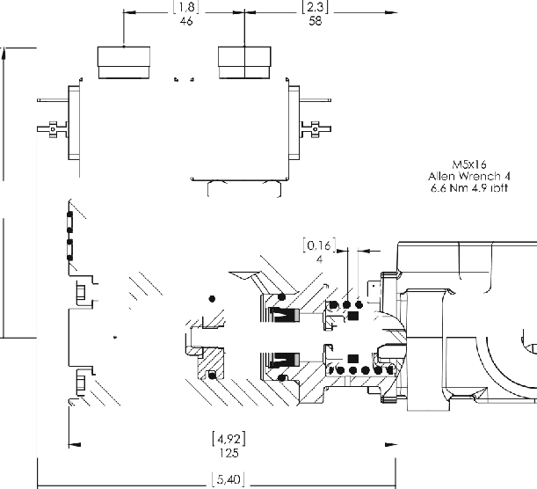
Alteiiiatif Ba kanti re tlidrolik Devre
Attention!
If tank pressure is more than 3 bar, an external drain line is recommended.
Dikkat!
Sistemde tank basinci 3 ban pe§mes/ durumunda sizinti hattinin bagimsiz o/arab ve direk
tanka baglanmasi oneri//r.

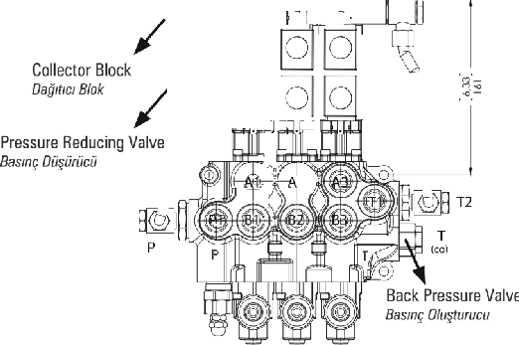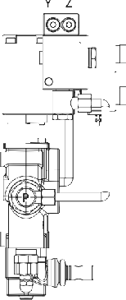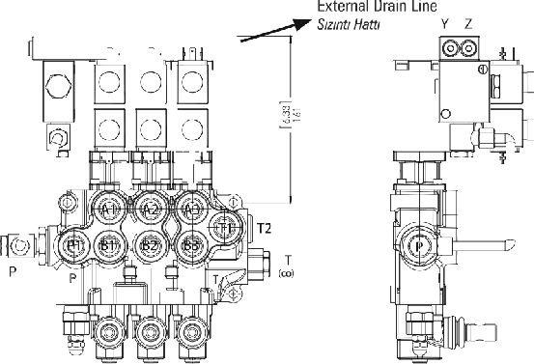
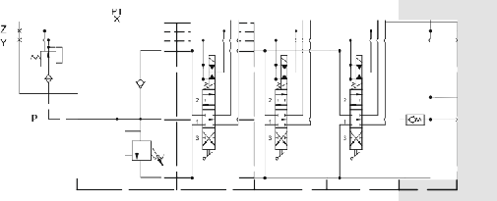
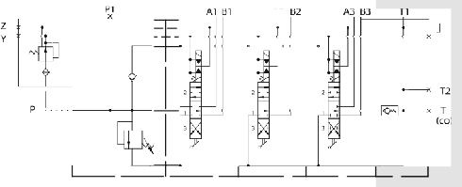


On-Off Direk Elektrik Kontrol

Max. 230 Bar / 3300 PSI
Working Pressure
]aIi#ma Basinci
Back Pressure
Tank Basinci
Internal Leakage
i r k
Stroke
5fro£
12VDC / C142
24VDC SC144
Voltage

Max. S Bar j!70 PSI

Max. 20 cc

*3 mm
Coil Connection Type
Bobin Baglanti Tipi
Suppy Voltage
Voltaj
Protection Type
Koruma
Nominal Voltage Tolerance
/Vomir/a/ Voltaj Toleransi
Duty cycle
6orev §evrimi
Absorbed Power
6’up

Coil Insulation Class
Yalitirn Sinifi
80W
+ 10%
I2VDC, 24VDC

OIN 43650
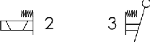

Allen wrench 4

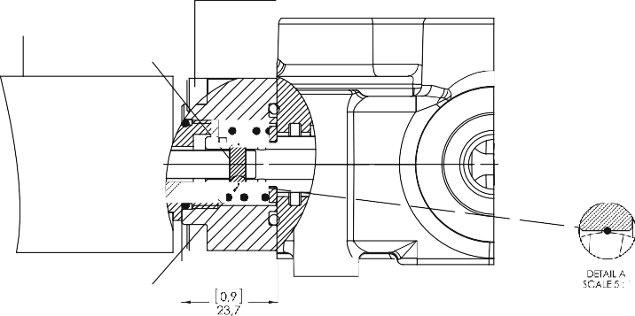IP65
Pim Selonoid Kontrol
10.5x0.3TelSegmon

100%

Olass ”H” l55°C

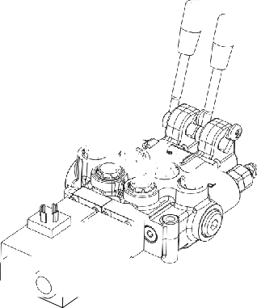
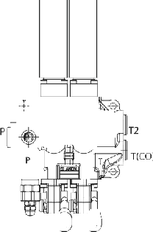
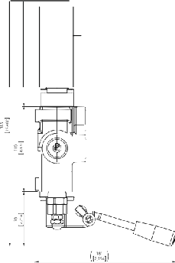

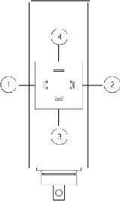
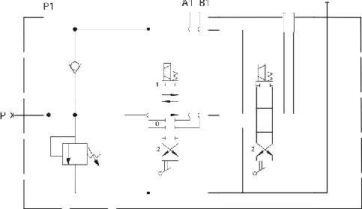CO)
A2 B2
' T2

T(
Connection / Baglanti
 | 1 2 | POS B | - • Negative Pole  Negatif Kutup  - • Spool Out (Pin In)  Pin /yerde  - • Spool In(Pin Out)  Pin Di#arda  4 • Ground Wire  Toprak Hatti
 | 1 - 3 | Port A

On-Off Direct Solenoid Control requires special machining on valve body,
equipped with special lever caps and spools.
0n-0ff Direk Elektrik itontrol, ifizel gifivde, sârgifi ve sap kapaklariyla iJretilrnektedir.

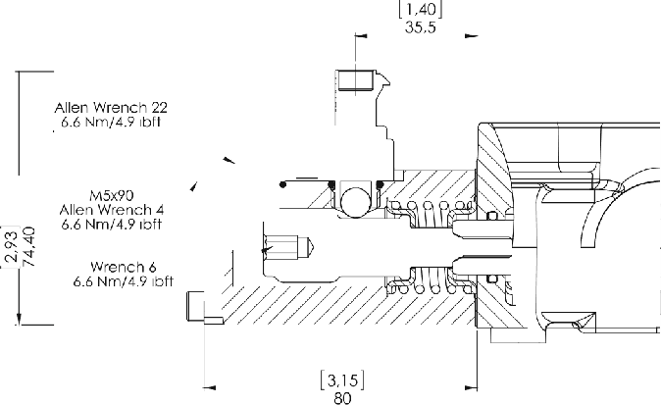
S C 1
3 Pozisyon, lift Tarafli Mikrosvi§ Kontrol (NK)

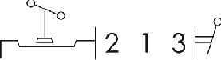

Stroke : + 5.5 mm

Configuration with normally open (N0) circuit is available, please contact our sales department.
Normalde Apik (NA) konfig5rasyon izin IiiIIen sand departmanimizla baglantiya gepiniz.

S C 1 8A
3 Pozisyon, 3.Pozisyona Mikrosvi§ Kontrol

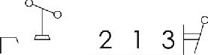

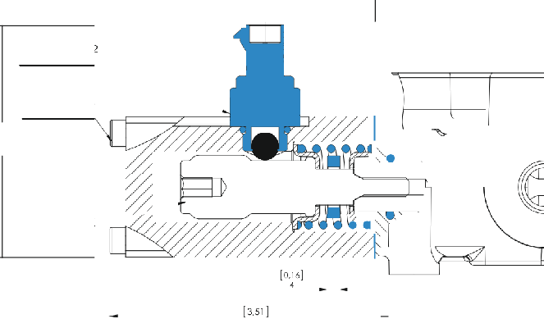Stroke : +5.5 mm
Allen Wrench 22

Allen wrench 4

S C 1 8 B
3 Pozisyon, 2.Pozisyona Mtkrosvi§ Kontrol

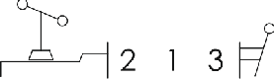

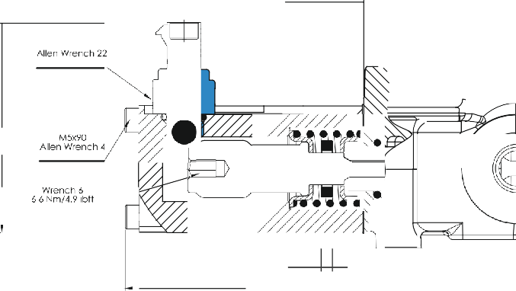Stroke : +5.5 mm

Spool Options
S‘ñfQ•“ !!“RIeri
AMV501A - R(180) / SC4 ST11 K3 / H

Spool Options
Surgu Tipleri

Spool Positions S“flrg“fl Pozisyonlari

1st Position
l. Pozisyon
Spool Neutral Position
/\/orr
2nd Position
2. Pozisyon
Spool In Position
Mil lperde
4th Position
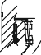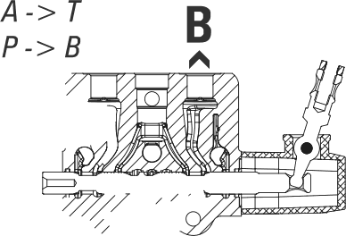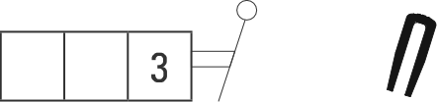4. Pozisyon
3rd Position
3. Pozisyon
Spool Out Position
Mil 0i§arda
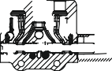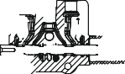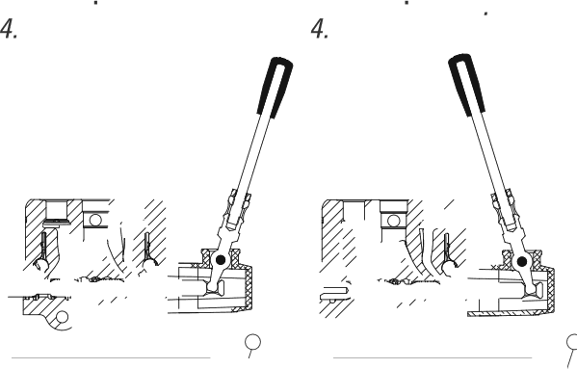4th Pos Spool Out 4th Pos Spool In
Pozisyon Mil Di#arda
Pozisyon Mil /yerde

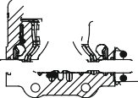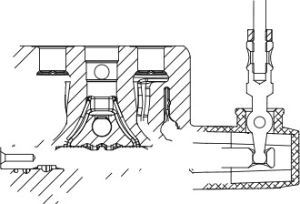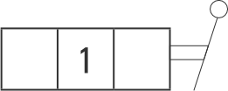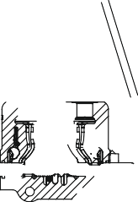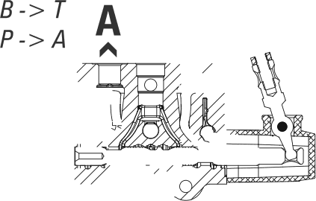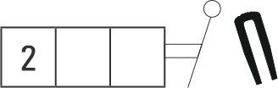2 3 4 2 1 3

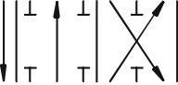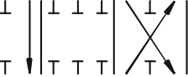 A B A B
3 Pozisyon, Kapali Merkez

ST 1

T
3 Pozisyon, §ih Etkili
2 1 T y
STD '

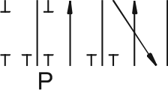 A A
3 Pozisyon, A Port Tek Etkili ve Tanka A§ik
T
3
ST2 3 Pozisyon, APot Tek Etkili ' 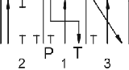

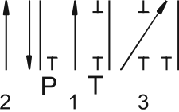
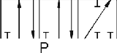 B B
3 PoGsyon,B PolTekEtkii
3 Pozisyon, B Port
Tek Etkili ve Tanka A§ik
T
3

T3 T

A B A B
3 Pozisyon, lift Etkili A ve B Tanka A§ik
3 Pozisyon,
lift Etkili ve A Tanka A§ik
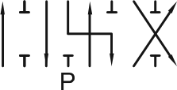
T
3
T
3

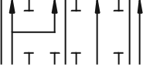ST8
3 Pozisyon,
lift Etkili ve B Tanka A§ik
3 Pozisyon,§ift Etkili 3.Pozisyonda Rejeneratif (Mil I§erde 2. Pozisyon)

A B
T
IXI
3

2 1
A B

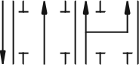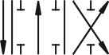 A B A B
4 Pozisyon, 4.Pozisyonda Float (Mil I§erde 4. Pozisyon)
3 Pozisyon, lift Etkili 2.Pozisyonda Rejeneratif (Mil Di§arda 3. Pozisyon)
T
T
3

4A 2
P 1 T 3

A B
4 Pozisyon, 4.Pozisyonda Float (Mil Di§arda 4. Pozisyon)
T
3 4B

A B
4 Pozisyon, 4.Pozisyonda Rejeneratif (Mil I§erde 4. Pozisyon)

A B
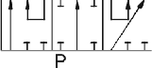
3 Pozisyon, Seri SurgiJ
T
3

A B
4 Pozisyon, 4.Pozisyonda Rejeneratif
(Mil Di§arda 4. Pozisyon)

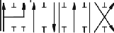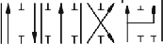

4A 2
P 1 T 3
2 P 1 T
3 4B


Lever Types

AMV501A - R(180) / SC4 ST11 K3 / H

Lever Types
Sap Tipleri
Ters montaj Sap Kapagi

NO
Standard Sap Kapagi
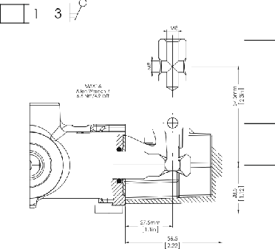CODE ’1
2

’2

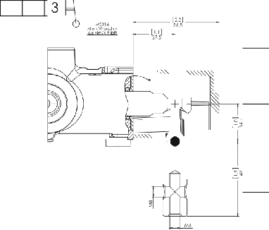2 1 3
Sap Kapaksiz
2

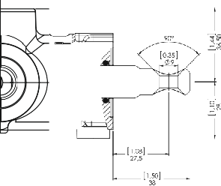

’3

22 11 33


GiJvenlik Kolu
Surgu Strok Kisitlayici

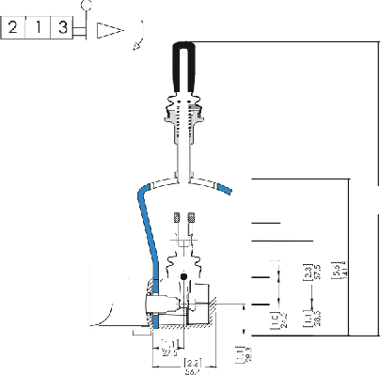
2 1 3
Toz Kapak

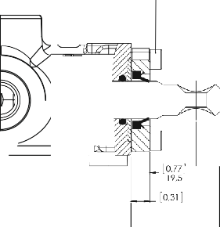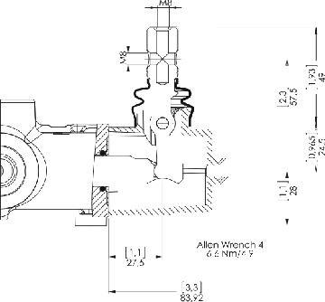


Ters Montaj Siirgii Strok Kisitlayici
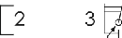
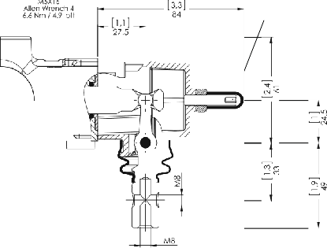
‘ °" T âf

Kablo Baglanti Kiti

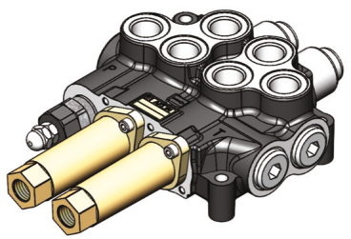
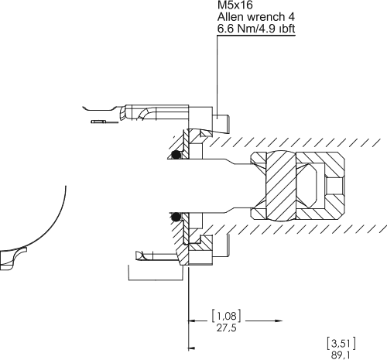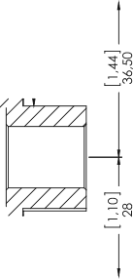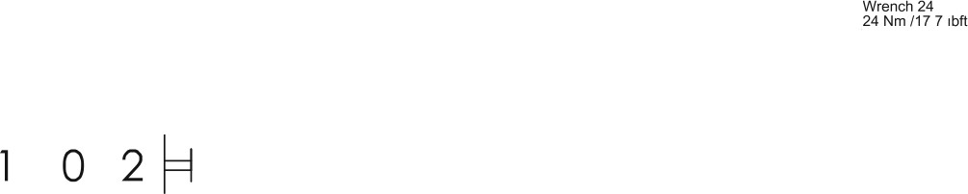

Lever Cable Remote Control
ffalat ffontro/
Cable remote control for Group of Levers
Halat Contra/ Srubu

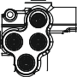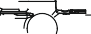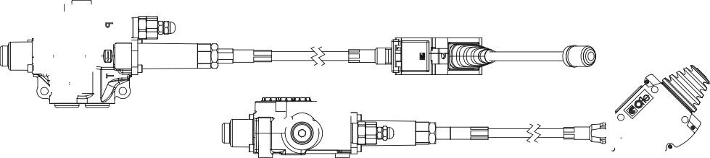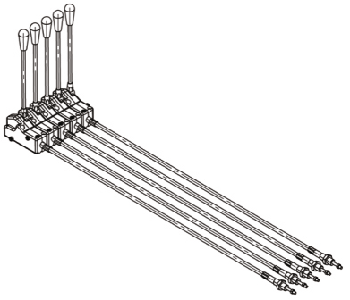
Lever cable remote control and cable remote control for group of levers are modular systems offering unlimited number of levers together through screws, also with many different configurations and cable lengths. Assembled on the valve only on request and extra charge. Please contact our sales department for details.
Halat kontrol ve halat kontrol grubu izin larkli uzunluklari mevcuttur. Halat Kontrol grubu ise talebe gore pe§itIi dilim sayilari izin ve pe§itIi uzunluklarda temin edilir. Kontrol grubu birbirine saplamlarla baglanmaktadir. Lutlen detayli bilgi izin satu departmanimizla baglantiya gepiniz.

Remote Joystick Control Joystik ffa/at/fontro/

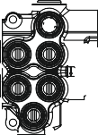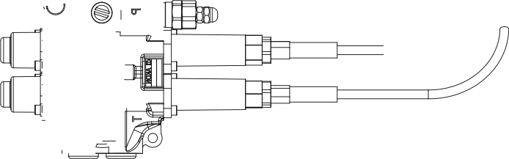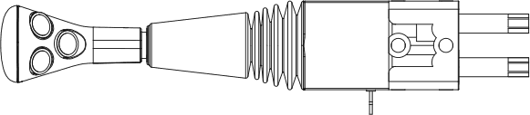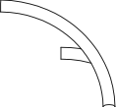Remote joystick control is available with several options. Please indicate the cable length demanded and contact our sales department for further demands.
Joystik halat kontrol farkli ye§/t ve uzunluklarda mevcuttur.
Id/fen satu departmanimizla baglantiya ge§iniz.

Joystick Control

Joysfik konfro/

Manuel Joystick Kontrol (Pivot Sol Ust)
A1

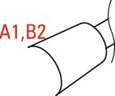A2
A1,A2
B2
B1,A2
B ,B2

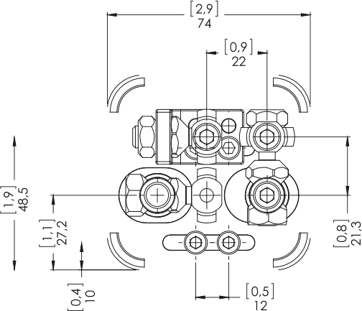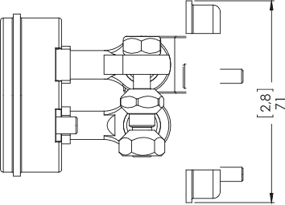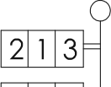BI K7 is standard configuration unless otherwise speficied.

22 1 3
Aksi beIiniImedik§e K7 sta»dan kontigurasyondur.

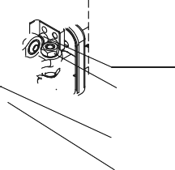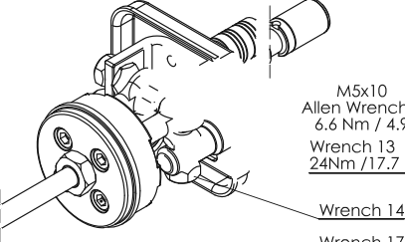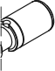K’ B
Allen WrenCh 4
°‘'%* ' '°*

Manuel Joystick Kontrol (Pivot Sag Ust)

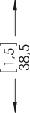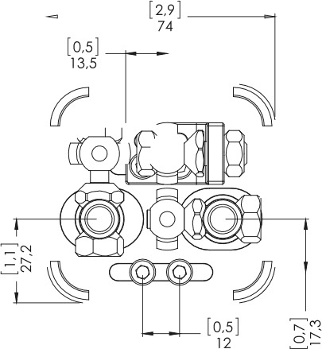A2

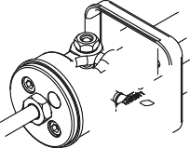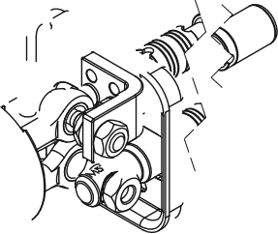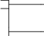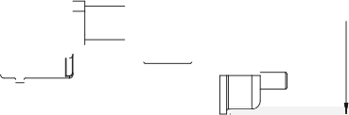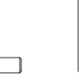BI
‹’
A2,B1 %

‘
B2,B1
B2,A1

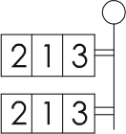B2

2 1 3

Manuel Joystick Kontrol (Pivot Sag Alt)

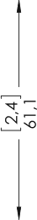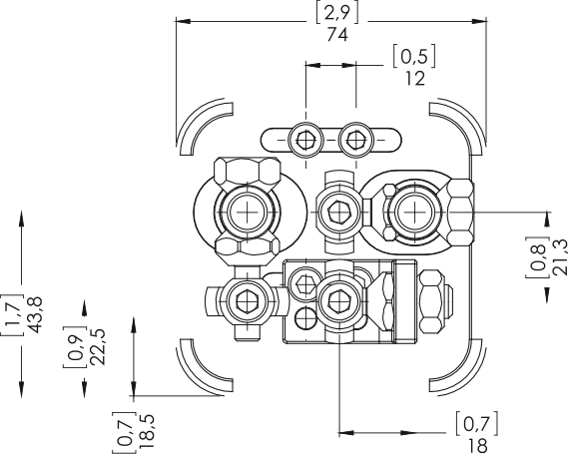B2

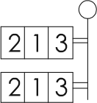
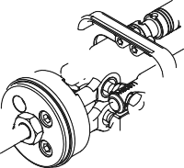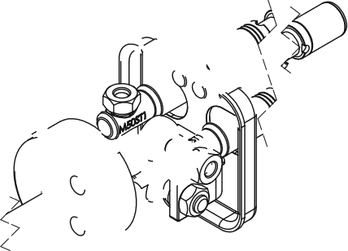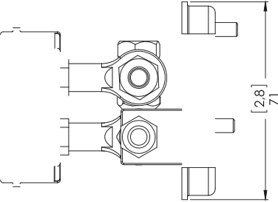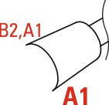BI
B2,B1
A2,B1
A2,A1

A2

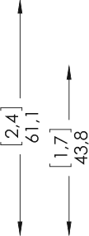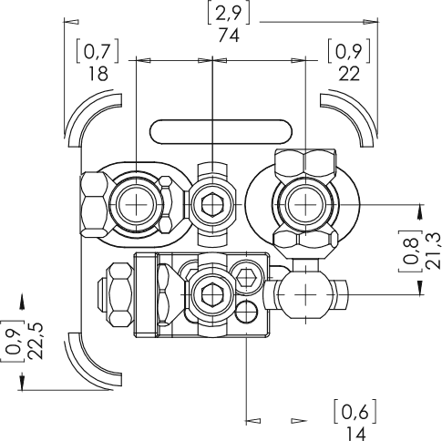K7 D

Manuel Joystick Kontrol (Pivot Sol Alt)

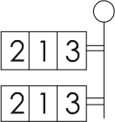
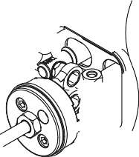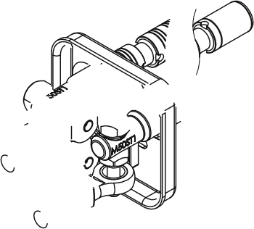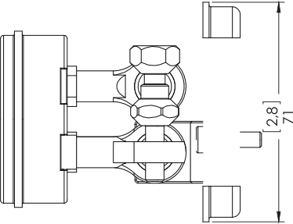BI
B1,A2
1,
°B2
A1,A2
A1,B2

A2

A1

Outlet Options
Tank (T) HaNi *R*f/ OJ?/d7?

AMV501A - R(180) / SC4 ST11 K3 / H

Outlet Options
Tank (T) Hatti Opsiyonlari

Standard Open Center Upper Outlet (TI open, T2 and T(C0) plugged)
NO
CODE
Standard Aqik Merkez (TI aqik, T2 ve T(60) k r)

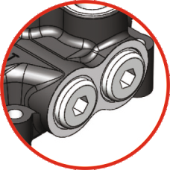
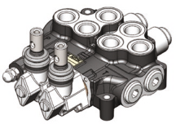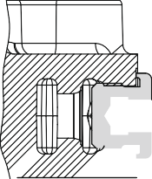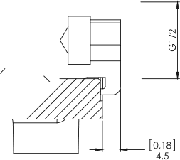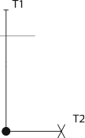)—
(

Outlet with Carry-Over

Please contact our sales department for other outlet options. 0zeI talepleriniz izin liitlen Satu Depanmani ml bagia»tiya gepin.


When Carry-Over is used for series connection with another valve,
T1 of the first valve must be connected to the tank.
Carry-over kullanildiginda, I.valfin tank hatti (TI) mutlaka tanka baglanmalidir.
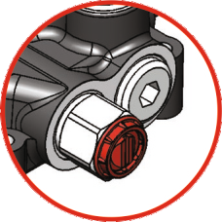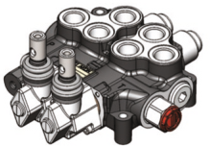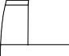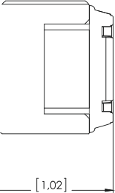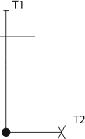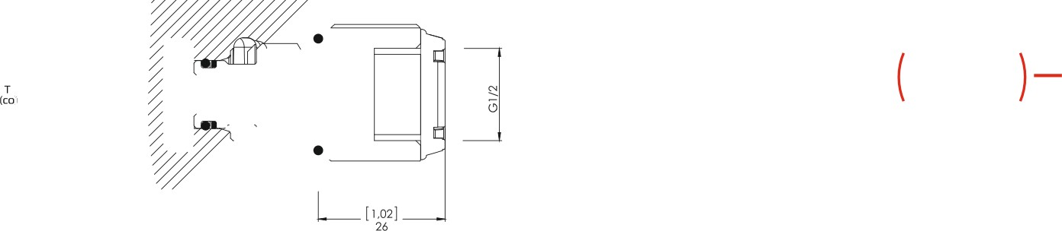

Outlet with Closed Center Plug
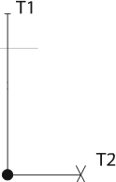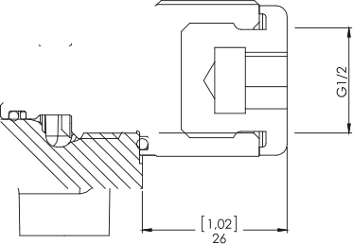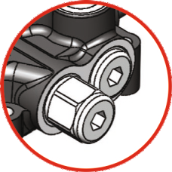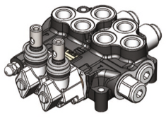Kapali Merkez


www.akon.com.tr

export@akon.com.tr sales@akon.com.tr

