The firm ltd “Agrokorm 2017”
produces the forage for cattle, pigs and poultry as well:

- Brewers’ grains (granular)- protein 25-28%, humidity 9-11%, cellulose 12,3%, fattiness 9-10%.
We sell the products all over Ukraine. Also we cooperate with foreign customers. Our partners are Trading firms in Poland, the Czech Republic, Lithuania, Latvia, Croatia, Hungary, Romania. We are ready to provide all accompanying documents. Monthly sales volume is more than 5000 tonnes. Manufacturing lines are located in Kiev and Khmelnitskiy regions.
Our firm is interested in collaborating with you. We will be glad if you consider our letter and have some collaboration offers. The documents about forage certification are available.
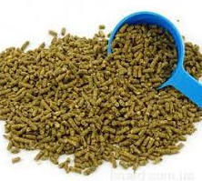
Contacts - telephone: +38 (066) 0397108 ; +38 (067) 3285025
E-mail: agrokorm_2017@ukr.net,
http://agrokorm-2017.in.ua.

Brewers’ grains
(granular)

